Software Engineering Laboratory

(BCS-609)

Timetable Management System

Submitted By

Bhargab das

Roll No: 2023/BCSE/0065

for

The Partial Fulfillment of the 6th Semester Examination

(Session: January – June, 2026)



Department of Engineering & Technology

BTECH COMPUTER SCIENCE & ENGINEERING

University of Science & Technology Meghalaya

Techno City, Killing Road,
Baridua, 9th Mile,
Ri-Bhoi, Meghalaya-793101
Department of Engineering & Technology
University of Science & Technology Meghalaya

Ref No. Date

Certificate

This is to certify that this laboratory record is the Bonafide work of Mr Bhargab Das, Department of Engineering & Technology, B.Tech Computer Science & Engineering, 6th Semester, Roll No. 2023/BCSE/0065, for the Academic Session 2025 – 2026.

This record contains the successfully completed programs for the course Software Engineering Laboratory, BCS-609. It is certified that the student has completed all the programs as prescribed in the syllabus for the academic semester.

The work presented here has been completed satisfactorily as per the requirements of the B.Tech curriculum.

Mr. Abdul Kayum Ali
Course Coordinator
Asst. Prof.
Programme: CSE/AI/DS
Dept. of E&T

Md. Jainul Abudin
PG Head, Dept. of E&T

TABLE OF CONTENTS
1. Chapter 1: Introduction
1.1 Introduction
1.2 Problem Statement
1.3 Proposed System
1.4 Objectives
2. Chapter 2: SDLC Model
2.1 The Agile Methodology
2.2 Application of Agile in NovaLearn
2.3 Agile Model Diagram
3. Chapter 3: Requirement Gathering Analysis
3.1 Requirement Gathering Process
3.2 Software Requirements Specification (SRS)
4. Chapter 4: Design
4.1 Data Flow Diagram (DFD)
4.2 Entity-Relationship (ER) Diagram
4.3 Use Case Model
4.4 Class Diagram
4.5 Object Diagram
4.6 Sequence Diagram
5. Chapter 5: Implementation
5.1 System Requirements
5.2 Coding and Module Descriptions
6. Chapter 6: Testing
6.1 Test Phases
6.2 Test Cases
7. Chapter 7: Output
7.1 Software Achievements
7.2 Application Snapshots
8. Chapter 8: Conclusion
8.1 Learnings
8.2 Future Scope
9. References

CHAPTER 1: INTRODUCTION

1.1 Introduction
E-learning has revolutionized the educational landscape, offering unprecedented accessibility and flexibility to students worldwide. However, standard video delivery platforms often lack the specialized interactive tools required for deep, retention-focused learning. NovaLearn is a comprehensive, full-stack e-learning web application designed to bridge the gap between passive video consumption and active student engagement. It provides a structured environment where educators can build rich courses and students can learn through interactive video players, assignments, quizzes, and a unique time-stamped note-taking system.

1.2 Problem Statement
Traditional video-based learning systems suffer from several critical drawbacks:
- Passive Learning: Students consume content passively without effective, synchronized ways to record their thoughts. Standard note-taking happens outside the platform, losing the context of the video timestamp.
- Lack of Role Separation: Many rudimentary platforms do not strictly separate the creator's workspace from the consumer's workspace, leading to cluttered interfaces and data privacy risks.
- Fragmented Assessment: Course delivery, assignment submission, and grading often occur across disparate, non-integrated platforms.

1.3 Proposed System
NovaLearn proposes an integrated, role-based architecture consisting of distinct Teacher and Student portals.
- For Students: The platform offers a clean dashboard to track progress, a video player integrated with real-time, timestamped notes that double as navigational bookmarks, and an assignment submission portal.
- For Teachers: The platform provides a dedicated dashboard to create courses, upload video content (both local files and YouTube links), issue assignments, and review or print student submissions.

1.4 Objectives

To develop a robust, secure authentication system with strict role-based access control (rbac) differentiating students and teachers.

To build an interactive video player that allows users to create, save, and jump to time-stamped notes, enabling active learning.

To design a comprehensive teacher dashboard for seamless course creation, video uploading, and assignment management.

To implement a flexible media delivery system that supports both external youtube embeds and secure local video file uploads.

To create an integrated assignment submission and review portal, allowing teachers to efficiently evaluate and print student work.

To build a scalable and stateless backend rest api using node.js, express, and sequelize orm to ensure rapid data retrieval.

To provide an intuitive, responsive, and modern ui/ux for students to easily track their enrolled courses and learning progress.

CHAPTER 2: SDLC MODEL

2.1 The Agile Methodology
For the development of NovaLearn, the Agile Software Development Life Cycle (SDLC) was chosen. Unlike the rigid Waterfall model, Agile promotes iterative development, continuous feedback, and rapid adaptation to changing requirements. The project was broken down into manageable "sprints," allowing for functional modules to be designed, developed, and tested concurrently.

2.2 Application of Agile in NovaLearn
The development was structured into the following sprints:
- Sprint 1 (Foundation): Setup of the MySQL database using Sequelize, Express server initialization, and core user authentication (JWT).
- Sprint 2 (Core Features): Development of the Student Dashboard, Course catalog, and basic Video playback.
- Sprint 3 (Interactive Elements): Implementation of the time-stamped note-taking system synchronized with the React video player.
- Sprint 4 (Instructor Portal): Architecting the Teacher Dashboard, course creation flows, custom local video uploads, and assignment grading systems.

2.3 Agile Model Diagram

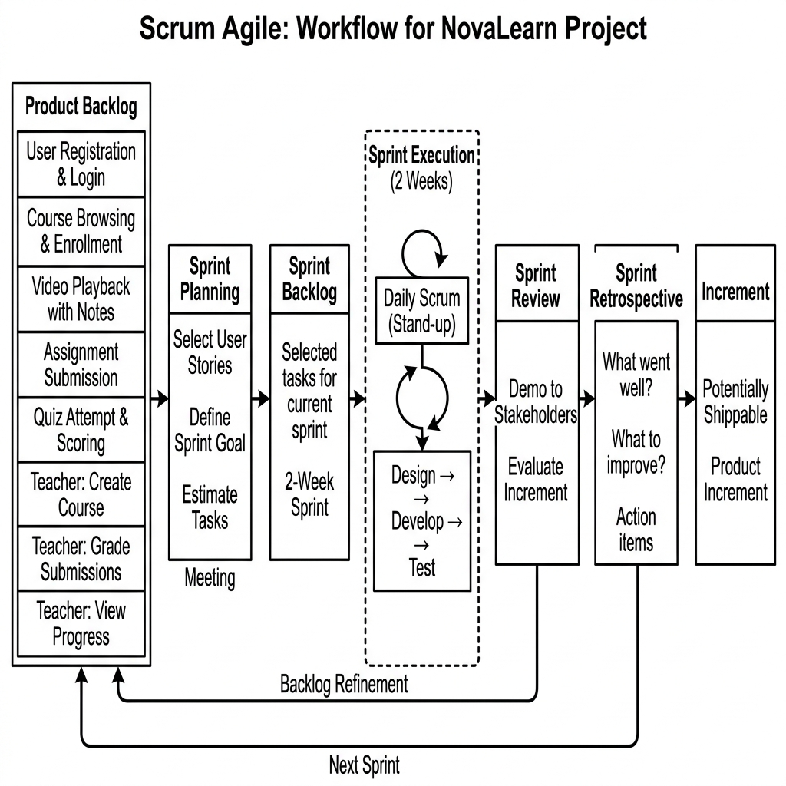

CHAPTER 3: REQUIREMENT GATHERING ANALYSIS

3.1 Requirement Gathering Process
Requirements were gathered through analysing existing e-learning platforms (like Coursera and Udemy) to identify missing interactive features. The primary focus was determined to be the integration of active learning tools (time-stamped notes) directly into the video consumption interface.

3.2 Software Requirements Specification (SRS)
Functional Requirements:
- Authentication: The system must allow users to register and login as either a 'Student' or 'Teacher'.
- Course Management: Teachers must be able to create courses, upload videos (local or YouTube), and create assignments.
- Video Player: The system must play videos and allow students to pause and add text notes linked to the exact second of the video.
- Submissions: Students must be able to submit text-based answers to assignments. Teachers must be able to view and print these submissions.
Non-Functional Requirements:
- Performance: The UI must be responsive and load course data within 2 seconds.
- Security: Passwords must be hashed using bcrypt, and all API routes must be protected via JWT authentication.
- Scalability: The backend REST API should be stateless to allow horizontal scaling.

CHAPTER 4: DESIGN

4.1 Data Flow Diagram (DFD)

LEVEL 0:

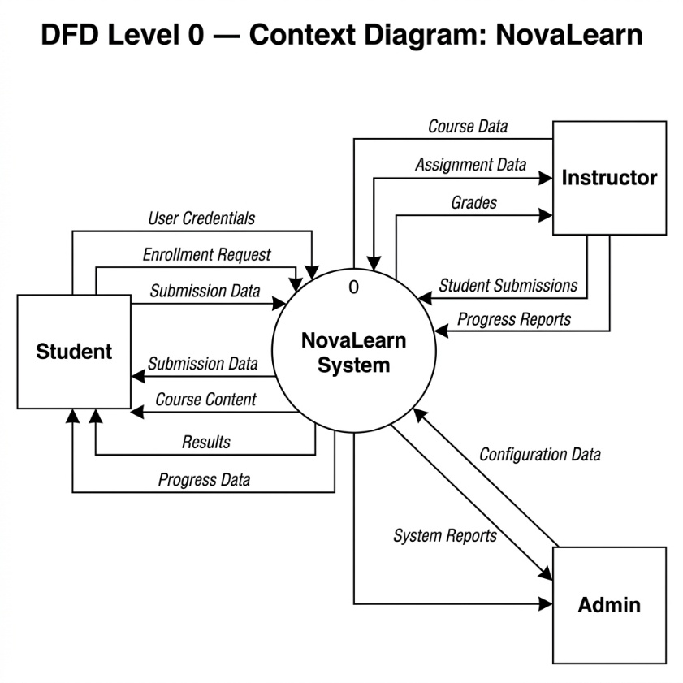

LEVEL 1:

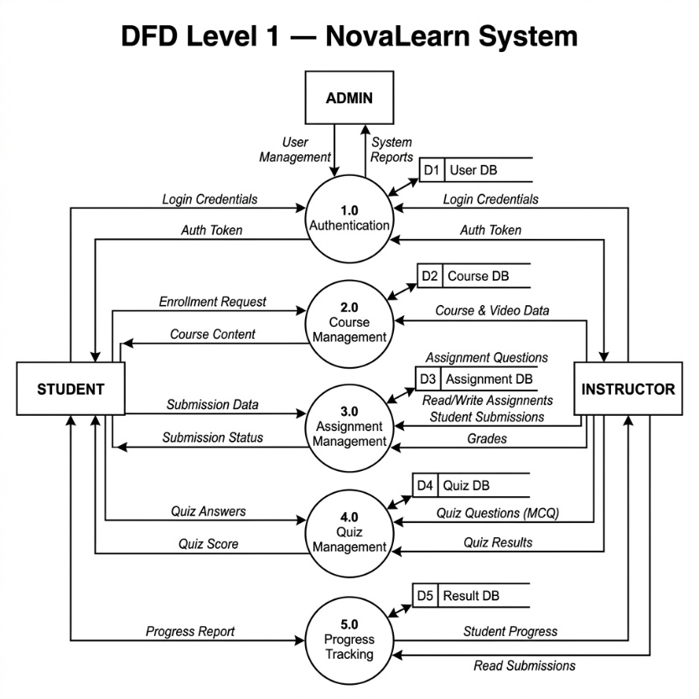

LEVEL 2:

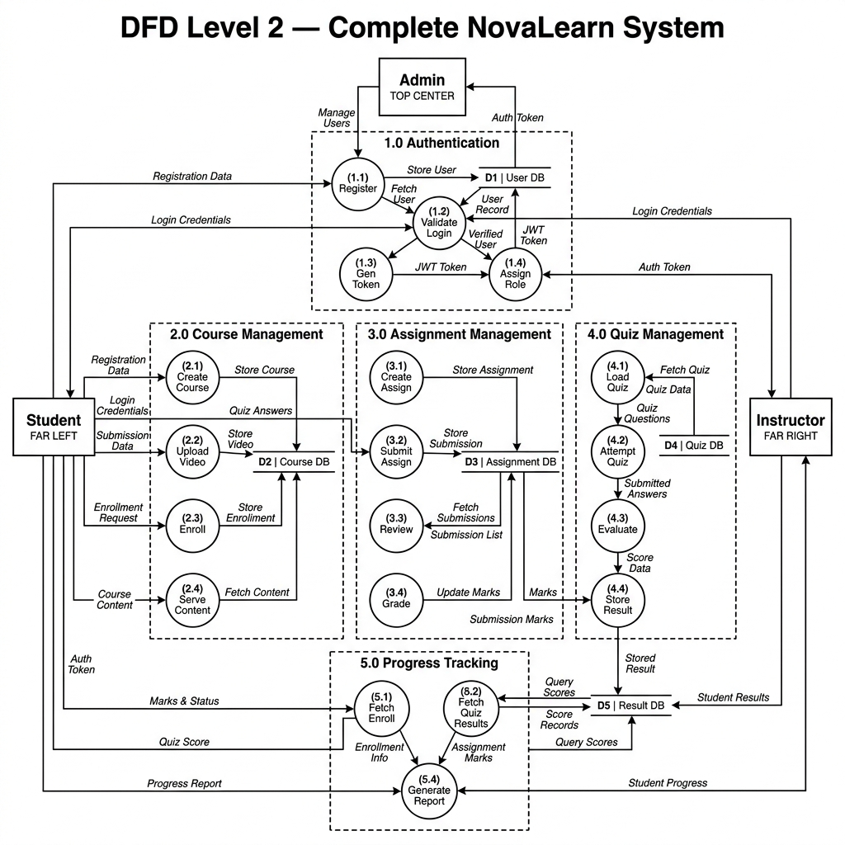

4.2 Entity-Relationship (ER) Diagram

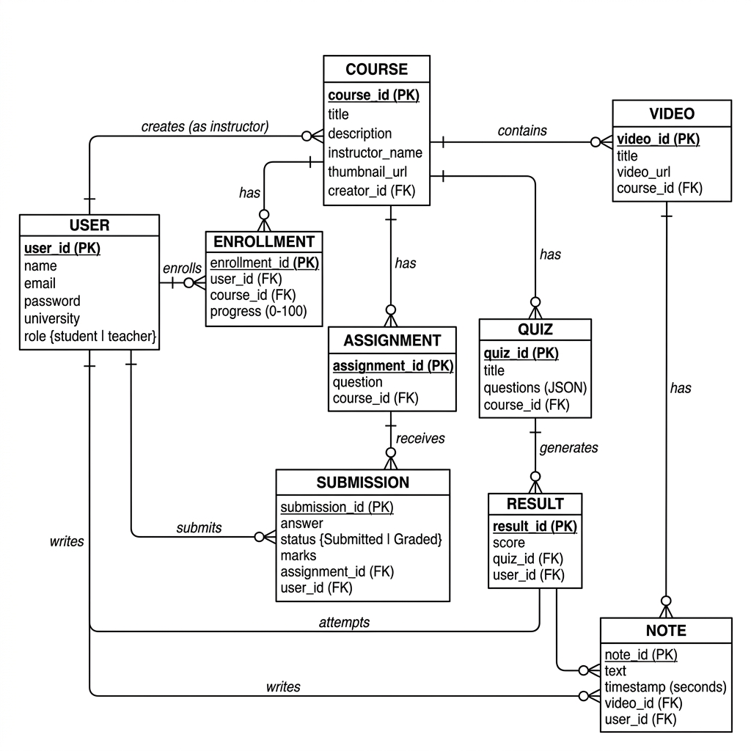

4.3 Use Case Model

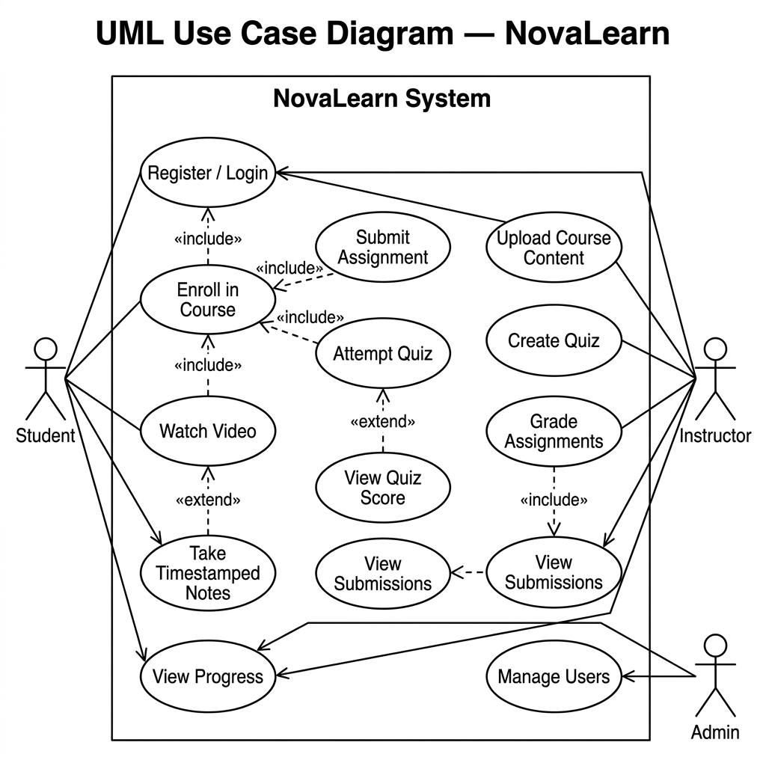

4.4 Class Diagram

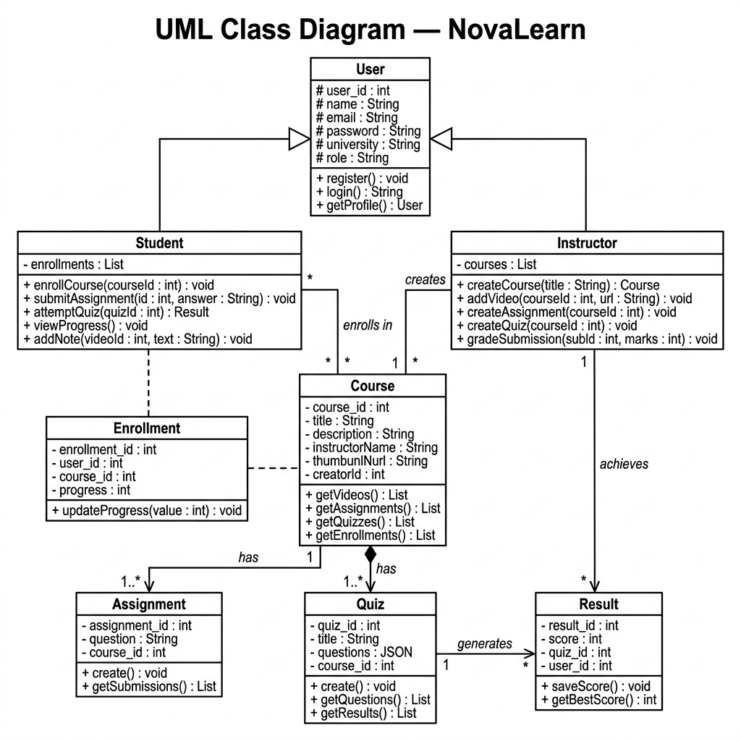

4.5 Object Diagram

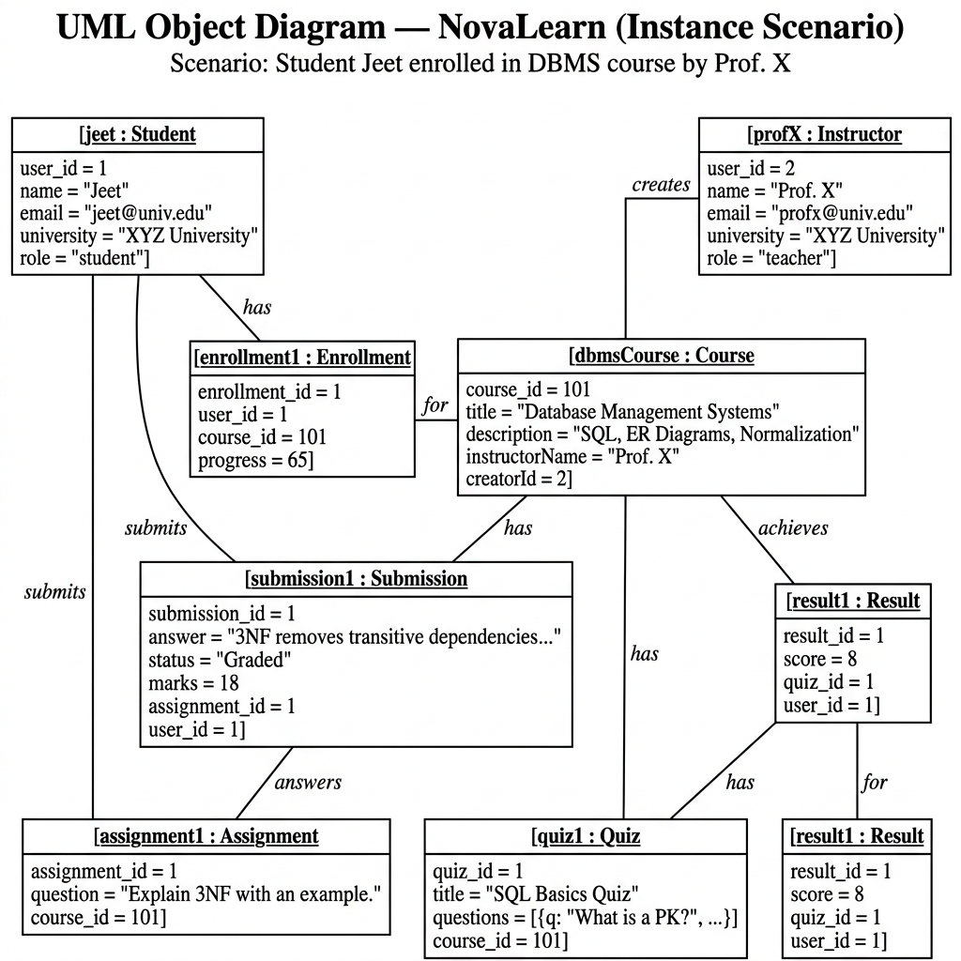

4.6 Sequence Diagram

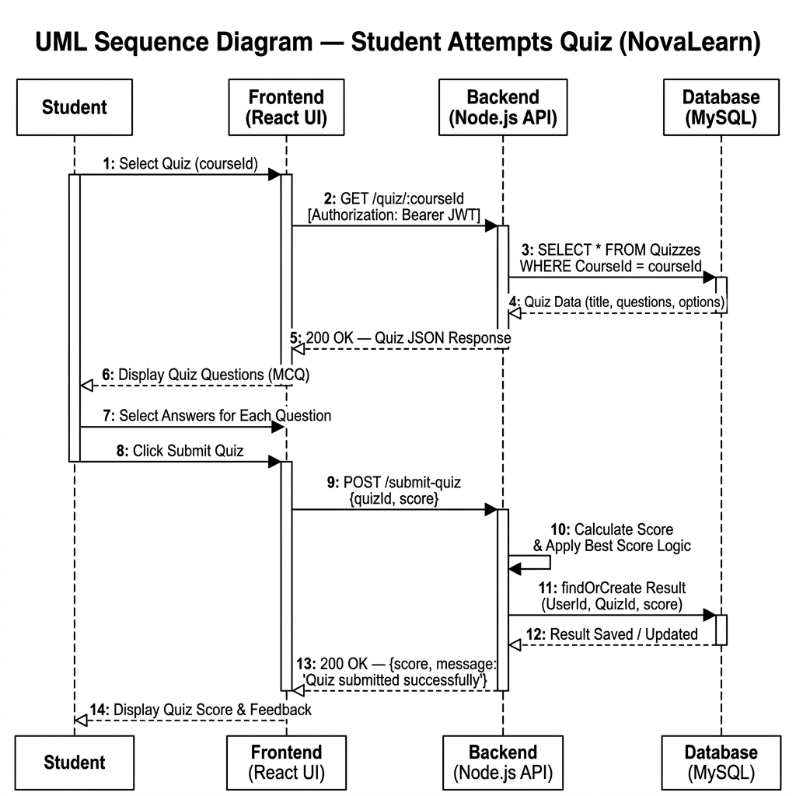

CHAPTER 5: IMPLEMENTATION

5.1 System Requirements
Table 3.1: Hardware Requirements
Component | Minimum Specification | Recommended Specification
Processor | Intel Core i3 or equivalent | Intel Core i5 or higher
RAM | 4 GB | 8 GB
Storage | 10 GB free space | 20 GB SSD
Table 3.2: Software Requirements
Component | Technology Used
Frontend | React.js, Vite, HTML5, CSS3, Lucide-React
Backend | Node.js, Express.js
Database | MySQL, Sequelize ORM
Dependencies | multer (uploads), bcrypt (hashing), jsonwebtoken

5.2 Coding and Module Descriptions

Coding:

1. Database Schema & Relationships (Sequelize ORM)

const User = sequelize.define('User', {

id: { type: DataTypes.INTEGER, primaryKey: true, autoIncrement: true },

name: { type: DataTypes.STRING, allowNull: false },

email: { type: DataTypes.STRING, allowNull: false, unique: true },

password: { type: DataTypes.STRING, allowNull: false },

role: { type: DataTypes.ENUM('student', 'teacher'), defaultValue: 'student' }

});

const Course = sequelize.define('Course', {

id: { type: DataTypes.INTEGER, primaryKey: true, autoIncrement: true },

title: { type: DataTypes.STRING, allowNull: false },

thumbnailUrl: { type: DataTypes.STRING, allowNull: true }

});

User.hasMany(Course, { foreignKey: 'CreatorId' });

Course.belongsTo(User, { as: 'Creator', foreignKey: 'CreatorId' });

Course.hasMany(Video, { onDelete: 'CASCADE' });

Video.belongsTo(Course);

2. Time-Stamped Video Notes Logic (React Frontend)

const handleAddNote = async (e) => {

e.preventDefault();

if (!newNoteText.trim()) return;

let currentTime = 0;

if (isYouTube(activeVideo.videoUrl)) {

if (player && typeof player.getCurrentTime === 'function') {

currentTime = player.getCurrentTime() || 0

}

} else {

if (nativePlayerRef.current) {

currentTime = nativePlayerRef.current.currentTime || 0;

}

}

await axios.post('http://localhost:5000/notes', {

videoId: activeVideo.id,

text: newNoteText,

timestamp: currentTime

});

};

3. Secure File Uploads (Multer & Express)

const multer = require('multer');

const storage = multer.diskStorage({

destination: (req, file, cb) => {

cb(null, 'uploads/');

},

filename: (req, file, cb) => {

cb(null, Date.now() + '-' + file.originalname);

}

});

const upload = multer({ storage });

app.post('/teacher/videos', authenticateToken, authorizeTeacher, upload.single('videoFile'), async (req, res) => {

let videoUrl = req.body.videoUrl;

if (req.file) {

videoUrl = `http://localhost:5000/uploads/${req.file.filename}`;

}

const video = await Video.create({ title, videoUrl, CourseId: courseId });

res.status(201).json(video);

});

4. Role-Based Security Middleware (JWT)

const authenticateToken = (req, res, next) => {

const authHeader = req.headers['authorization'];

const token = authHeader && authHeader.split(' ')[1];

if (!token) return res.status(401).json({ error: 'Access denied' });

jwt.verify(token, 'secret_key', (err, user) => {

if (err) return res.status(403).json({ error: 'Invalid token' });

req.user = user;

next();

});

};

const authorizeTeacher = (req, res, next) => {

if (req.user.role !== 'teacher') {

return res.status(403).json({ error: 'Forbidden: Teacher access required' });

}

next();

};

Module Descriptions:
The application follows an MVC (Model-View-Controller) pattern adapted for a RESTful API architecture.
Module 1: Authentication & Authorization
Uses JWT to verify users. Middleware restricts access to course creation routes.
Module 2: Time-Stamped Video Notes
The frontend utilizes a hook attached to the HTML5 video element or the React-YouTube player to extract the exact current Time when a user submits a note.
Module 3: Local Video Uploads via Multer
Allows teachers to upload heavy video files directly to the server, serving them statically.

CHAPTER 6: TESTING

6.1 Test Phases
- Unit Testing: Individual UI components (like the custom video player and note submission form) were tested for rendering and state updates.
- Integration Testing: Ensuring the React frontend correctly communicated with the Express backend, verifying JWT tokens were passed in headers correctly.
- System Testing: End-to-end testing of user flows, such as a teacher creating a course and a student subsequently enrolling and viewing it.

6.2 Test Cases
Table 6.1: Authentication Test Cases
Test Case ID | Description | Expected Result | Status
TC_01 | Login with invalid password | Returns 401 Unauthorized error | Pass
TC_02 | Register as Teacher | Teacher dashboard unlocks upon login | Pass
Table 6.2: Core Functionality Test Cases
Test Case ID | Description | Expected Result | Status
TC_03 | Click timestamp button on note | Video seeks exactly to the saved time | Pass
TC_04 | Upload local MP4 video file | File saves to /uploads and plays natively | Pass
TC_05 | Print student submissions | Sidebar hides, submissions expand to full width | Pass

CHAPTER 7: OUTPUT

7.1 Software Achievements
The NovaLearn application successfully fulfils all proposed objectives. We achieved a highly responsive, aesthetically pleasing interface that dynamically adapts based on the user's role. The integration of local file uploads alongside YouTube embeds gives instructors immense flexibility, while the time-stamped note system significantly enhances the student's cognitive engagement with the material.

7.2 Application Snapshots

Student Sign Up:

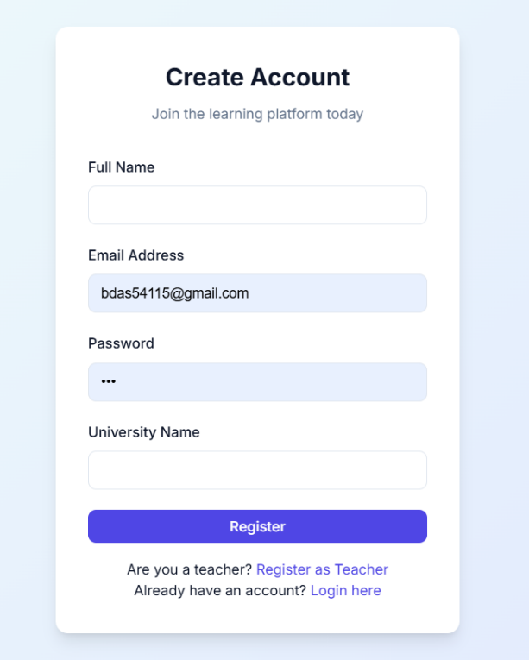

Teacher Sign Up:

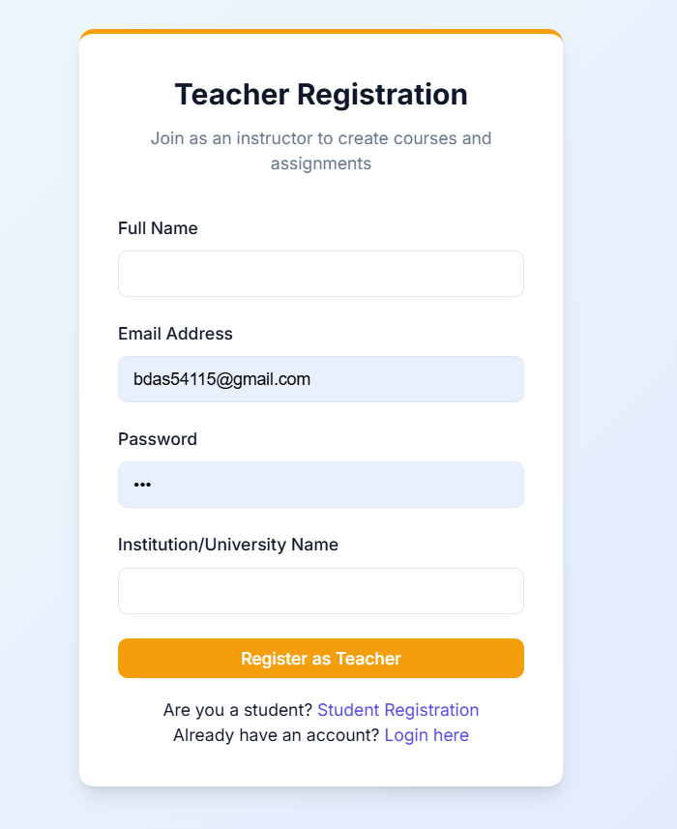

LogIn:

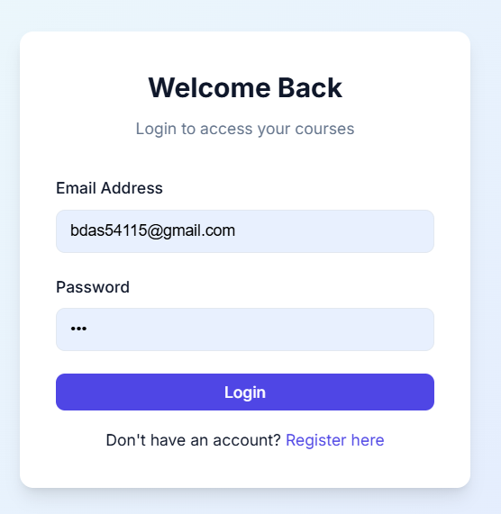

Teacher Dashboard:

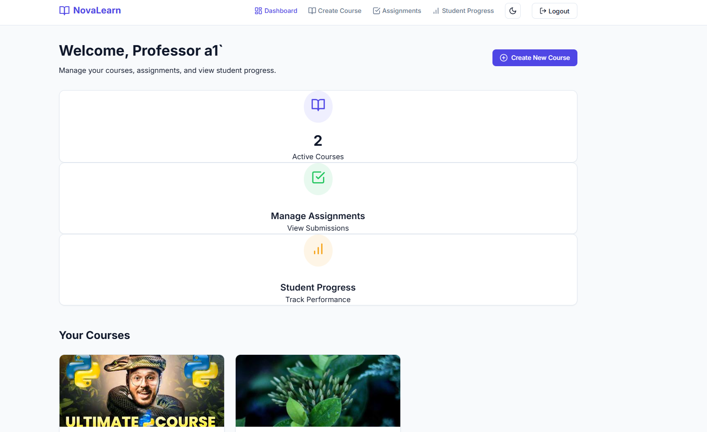

Student Dashboard:

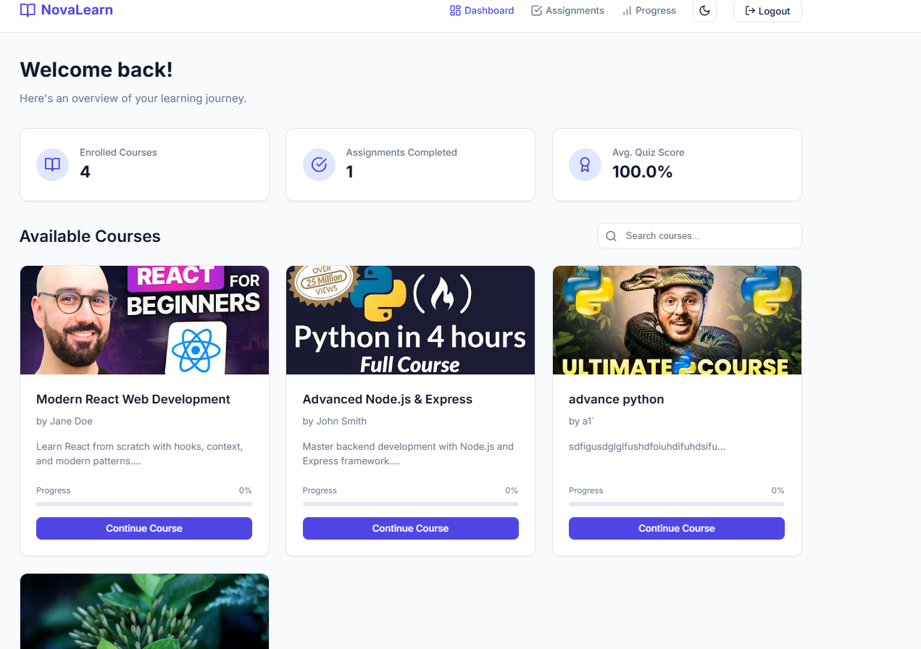

CHAPTER 8: CONCLUSION

8.1 Learnings
Developing NovaLearn provided deep, practical insights into full-stack web development. Key learnings included:
- Architecting relational databases using Sequelize ORM to handle complex associations (Users, Courses, Videos, Notes).
- Implementing secure, role-based access control using JSON Web Tokens.
- Handling multipart/form-data for file uploads using Multer.
- Managing complex React state and interacting with DOM APIs for video synchronization.

8.2 What we have done (Achievements)
We successfully transitioned a conceptual idea into a fully functional software product. By prioritizing the user experience—such as adding dynamic course thumbnails and printer-friendly CSS layouts for teachers—the application moves beyond a mere technical demonstration into a viable, production-ready educational tool.

REFERENCES
- React Documentation. (n.d.). React – A JavaScript library for building user interfaces. Retrieved from https://reactjs.org/
- Node.js Foundation. (n.d.). Node.js. Retrieved from https://nodejs.org/
- Sequelize. (n.d.). Sequelize: The Node.js ORM. Retrieved from https://sequelize.org/
- Express.js. (n.d.). Fast, unopinionated, minimalist web framework for Node.js. Retrieved from https://expressjs.com/
- React-YouTube Library. (n.d.). NPM Registry. Retrieved from https://www.npmjs.com/package/react-youtube

